1. Searching for ejournal/ebook titles
2. Searching for datasets
3. RAVEN/institutional logins

1. Searching for ejournal/ebook titles
To search for ejournals please use iDiscover. When you locate the resource, you are searching for, click on the title instead of clicking on ‘Online access’.
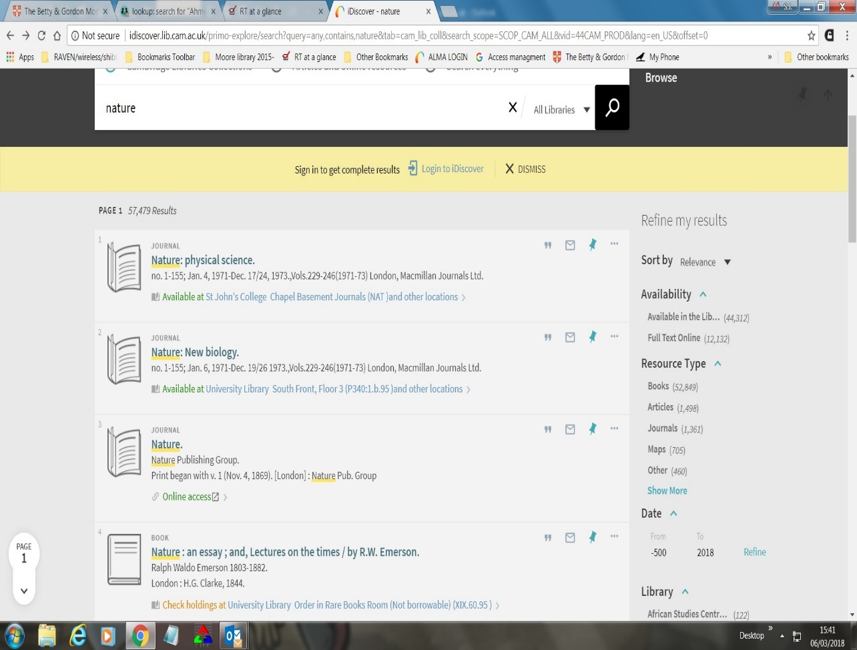
At the next screen click ‘VIEW IT’ in the left-hand column.

This will give you the full range of access options for your title – which is useful if there are more than one. Select the one relevant to your article and click the publisher link to take you to the article.

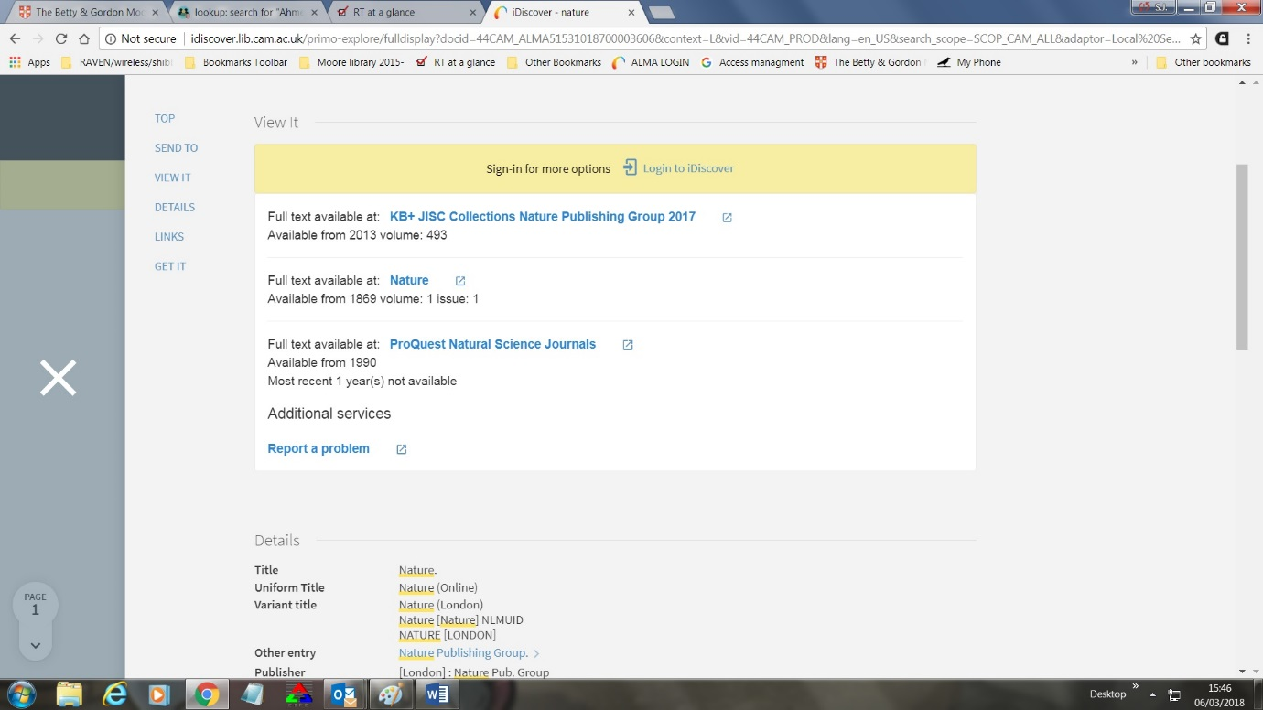

If you only click ‘Online access’ you are taken to the first publisher site in the list. By clicking the title you will see the entire range of coverage for that title – which may be spread over multiple publisher sites.
This is less likely to be an issue when searching for ebooks so clicking ‘Online access’ for that type of search should fine. There is further information regarding searching for ebooks here

2. Database searching
To search for databases available to users please use the eresource LibGuide. Enter the database title in the search box or use the ‘or: Browse by subject, title, vendor or type’ option. You can also search using the A-Z Database List.

3. RAVEN/institutional logins
When you follow the link, for the resource you are wishing to access, if a RAVEN login page doesn't first appear and you don't have full access or are off-campus a login is required. You will need to find and click on a login link that will identified by one of the following:
• Shibboleth login
• Login via your home institution
• Institutional login
• UK Federation
• UK Federation management

1. Click on the Shibboleth/Institutional Login link. For accessing JSTOR see below
2. Under the "please choose your institution's location section click the down arrow and select UK Access Federation Management or UK Federation and click Go.
3. From the list that appears select University of Cambridge.
4. A RAVEN login box will appear and you should now enter your details.
5. You will be returned to the start page and the words Logged in via University of Cambridge now appear at the top right hand side of the screen. You are now ready to use the service.
If your starting point had been a journal then you will be returned to the specific journal page.

Accessing JSTOR via Shibboleth

1. Select "Login" from the top right hand corner of of any JSTOR page or go direct to https://www.jstor.org/action/showLogin .
DO NOT CLICK ATHENS LOGIN
2. Under "Access through a participating institution", halfway down on the login page, select UK and then University of Cambridge and click login
3. You will then be redirected to the RAVEN authentication page where you should enter your account details.
4. You will be returned to the start page and the words Logged in via University of Cambridge now appear at the top right hand side of the screen. You are now ready to use the service.

